- INTRODUCTION

The purpose of this document is to provide a design and implementation plan for the deployment of Microsoft Systems Management Server 2.0 SP2 (SMS) into the Courts division. The deployment of SMS will go hand-in-hand with the Windows 2000 deployment scheduled to begin in September, 2001. The primary objective of this deployment is to provide the Department of Justice (DOJ) with a dynamic asset tracking system, and to acquire hardware and software inventory for future planning. Future objectives may include software distribution, remote tools and licence metering.

Implementation of SMS into the Courts division is a challenging undertaking due to the diverseness of the DOJ network. The design must encompass 37 sites scattered throughout Western Australia, with the number of workstations in excess of 800 units. There are some unknowns, but due to time constraints, the design will be based on current information.

This design is based upon an earlier design proposed before significant network changes were known, and builds upon that design, mainly in the Network structure

- EXECUTIVE SUMMARY

The ‘SMS for Courts’ design process has undertaken the following steps:

- Determine the objectives of the SMS design
- Summarise the existing Courts network infrastructure

The main objectives for using SMS in the Courts division have been summarised below:

- Provide a dynamic asset tracking system
- Provide detailed hardware and software inventory of all workstations and servers

A detailed discussion of all outcomes can be found in sections 3, 4 and 5.

- SMS DESIGN OBJECTIVES

CSC has been asked by DOJ to provide an SMS infrastructure for the Courts division to coincide with the Windows 2000 rollout scheduled for September, 2001. The proposed implementation will provide the Department of Justice with a method of tracking all newly rolled out hardware, and to acquire comprehensive hardware and software data. At this stage, the application of SMS software distribution and remote tools capabilities will not be undertaken.

3.1 Asset Tracking

The primary objective of the SMS implementation in Courts is to provide DOJ with a dynamic asset tracking mechanism. This mechanism will be used to track workstation and server hardware that is deployed as part of the Windows 2000 rollout. Having an up-to-date and accurate asset list has several advantages including:

- Baseline for future planning when equipment is required to be updated
- Tracking the ‘age’ of equipment to ascertain warranties
- Helping to determine software licensing needs

3.2 Hardware Inventory

This facility will be used to build and maintain a database of information detailing the hardware specifications of all Courts division workstations and servers. This information is vital for determining the overall ‘age’ of the workstation/server fleet, planning for future upgrade, and for determining whether individual units have the minimum specifications to run new operating systems and applications.

3.3 Software Inventory

This facility will be used to build and maintain a database of information detailing the software that is installed on all Courts division workstations and servers. This information will help to determine software licensing requirements, and whether users are running unauthorised software on their workstations.

3.4 Future Capabilities

SMS has other capabilities that have not been factored into the Courts design, but could be added at a later date if required.

3.4.1 Software Distribution

This facility is used to deploy software packages and ‘fixes’ to any workstation from a central location, allowing the upgrade of software to remote sites without support staff having to visit the site.

3.4.2 Remote Tools

The remote tools facility is a suite of utilities that allow helpdesk staff to provide support to users across the network. This is particularly useful when the PC is situated in a remote location. The utilities provided as part of the suite include remote control, remote file transfer, remote reboot and remote execution.

3.4.3 Licence Metering

This option allows the collection of licence data for applications and, in its fullest form, the ability to provide real-time licence allocation to individual workstations. Licence metering is an extremely

resource-intensive facility and should only be implemented when the proper infrastructure has been put in place.

3.5 Minimal Impact on Users

The implementation of SMS into the Courts environment should be accomplished with minimal disturbance to the users. SMS components that will operate on workstations will have no user interaction where possible, and have minimal impact on the performance of the PC.

- COURTS DIVISION NETWORK INFRASTRUCTURE

The following section details the existing Courts network infrastructure and outlines the proposed changes when the Windows 2000 rollout commences. The success of the implementation of SMS into the Courts division will depend greatly on the network structure that is in place when the product is deployed. Although SMS can be ‘tuned’ to make the most of network bandwidth, it can perform badly in poor environments.

4.1 Overview

The Courts division network is a subset of the overall Department of Justice network. It encompasses 37 sites which are spread throughout Western Australia. An audit of all Courts locations was carried out in October – November, 2000. Every workstation was located and vital information recorded. The workstation figures used in this document are derived from this audit.

Approximately 75% of the Courts sites will be receiving new servers as part of an infrastructure upgrade. The remaining 25% will be retaining their existing server infrastructure. It was important to analyse each server’s hardware to ascertain whether they have the correct minimum specifications to become an SMS site server.

Installation of the SMS client software will utilise workstation resources. It is important to make sure that all PC’s have the ability to run the SMS client software with little impact on the overall performance of the workstation.

4.2 Courts Locations

The Courts division has 37 sites scattered throughout Western Australia (rural and metro areas). All information concerning workstation numbers is based on the audit carried out on all Courts sites at the end of last year.

4.2.1 Site Classification

For the purpose of the design process, the Courts sites have been classified according to the number of workstations that are to be installed as part of the Windows 2000 rollout. A table outlining these classifications is shown below.

Site Classification | Number of Workstations | Number of Courts Locations
Small | < 10 | 19
Medium | 10 – 50 | 15
Large | > 50 | 3
Table 4.1 – Site Classifications

4.2.2 Site Details

The Courts division has 37 identifiable production sites, with some sites housing more than one business unit e.g. District and Magistrates Court are both housed at the Central Law Courts site. The following table outlines the location, number of workstations and the classification of each site.

Name | Location | PC Count | Classification
Albany Court | 184 Stirling Terrace, Albany | 12 | Medium
Armadale Court | 190 Jull Street, Armadale | 14 | Medium
AXA Building | 111 St. Georges Terrace, Perth | 26 | Medium
Broome Court | Hammersley Street, Broome | 7 | Small
Bunbury Court | 3 Stephen Street, Bunbury | 15 | Medium
Busselton Justice Complex | Adelaide Street, Busselton | 15 | Medium
Carnarvon Court | Robinson Street, Carnarvon | 5 | Small
Children's Court |  | 28 | Medium
Collie Court | Wittenoom Street, Collie | 4 | Small
Coroner's Court | 172 St. Georges Terrace, Perth | 20 | Medium
Derby Court | Loch Street, Derby | 2 | Small
District Court  Magistrates Court | 30 St. Georges Terrace, Perth | 185 | Large
Esperance Court | Dempster Street, Esperance | 2 | Small
Family Court |  | 112 | Large
Fremantle Justice Complex |  | 19 | Medium
Geraldton Court | Marine Terrace, Geraldton | 14 | Medium
Guardianship Board | 20 Terrace Road, East Perth | 31 | Medium
Joondalup Court | 21 Reid Promenade, Joondalup | 22 | Medium
Kalgoorlie Court | 54-68 Brookman Street, Kalgoorlie | 14 | Medium
Karratha Court |  | 9 | Small
Katanning Court | Clive Street, Katanning | 2 | Small
Kununurra Court | Coolibah Drive, Kununurra | 4 | Small
Mandurah Court | 333 Pinjarra Road, Mandurah | 4 | Small
Manjimup Court | Mount Street, Manjimup | 2 | Small
Merredin Court | 22 Mitchell Street, Merredin | 3 | Small
Midland Court | 24 Spring Park Road, Midland | 14 | Medium
Moora Court | Dandaragan Street, Moora | 2 | Small
Narrogin Court | Fortune Street, Narrogin | 2 | Small
Northam Court | 118 Wellington Street, Northam | 3 | Small
Parole Board |  | 8 | Small
Pinjarra Court | South West Highway, Pinjarra | 2 | Small
Port Hedland Justice Complex |  | 9 | Small
Rockingham Justice Complex |  | 16 | Medium
Roebourne Court | Hampton Road, Roebourne | 3 | Small
Small Claims Tribunal | 81 St. George’s Terrace, Perth | 8 | Small
Supreme Court | Barrack Street, Perth | 105 | Large
Victim Support Services | 32 St. Georges Terrace, Perth | 11 | Medium
Table 4.2 – Site Details

4.2.3 Local Area Network

All Courts division sites are running 10M Ethernet on their respective local area networks, with some of the bigger sites running a 100M fibre backbone. The IP addressing scheme is all Class C. The following table outlines the subnet information for each Courts division site.

Name | IP Subnet | Subnet Mask | Speed
Albany Court | 89.91.0.0 | 255.255.255.0 | 10M
Armadale Court | 89.9.0.0 | 255.255.255.0 | 10M
AXA Building | 89.2.17.0 | 255.255.255.0 | 10M
Broome Court | 89.70.0.0 | 255.255.255.0 | 10M
Bunbury Court | 89.86.0.0 | 255.255.255.0 | 10M
Busselton Justice Complex | 89.20.162.0 | 255.255.255.0 | 10M
Carnarvon Court | 89.74.0.0 | 255.255.255.0 | 10M
Children's Court | 89.8.0.0 | 255.255.255.0 | 10M
Collie Court | 89.87.0.0 | 255.255.255.0 | 10M
Coroner's Court | 89.20.36.0 | 255.255.255.0 | 10M
Derby Court | 89.97.0.0 | 255.255.255.0 | 10M
District Court  Magistrates Court | 89.15.0.0 | 255.255.255.0 | 10M, 100M backbone
District Court  Magistrates Court | 89.1.0.0 | 255.255.255.0 | 10M, 100M backbone
Esperance Court | 89.93.0.0 | 255.255.255.0 | 10M
Family Court | 89.20.36.0 | 255.255.255.0 | 10M
Fremantle Justice Complex | 89.20.44.0 | 255.255.255.0 | 10M
Geraldton Court | 89.77.0.0 | 255.255.255.0 | 10M
Guardianship Board | 89.20.41.0 | 255.255.255.0 | 10M
Joondalup Court | 89.11.0.0 | 255.255.255.0 | 10M
Kalgoorlie Court | 89.30.0.0 | 255.255.255.0 | 10M
Karratha Court | 89.73.0.0 | 255.255.255.0 | 10M
Katanning Court | 89.92.0.0 | 255.255.255.0 | 10M
Kununurra Court | 89.94.0.0 | 255.255.255.0 | 10M
Mandurah Court | 89.83.0.0 | 255.255.255.0 | 10M
Manjimup Court | 89.89.0.0 | 255.255.255.0 | 10M
Merredin Court | 89.81.0.0 | 255.255.255.0 | 10M
Midland Court | 89.6.0.0 | 255.255.255.0 | 10M
Moora Court | 89.79.0.0 | 255.255.255.0 | 10M
Narrogin Court | 89.85.0.0 | 255.255.255.0 | 10M
Northam Court | 89.80.0.0 | 255.255.255.0 | 10M
Parole Board | 89.118.0.0 | 255.255.255.0 | 10M
Pinjarra Court | 89.84.0.0 | 255.255.255.0 | 10M
Port Hedland Justice Complex | 89.71.0.0 | 255.255.255.0 | 10M
Rockingham Justice Complex | 89.20.65.0 | 255.255.255.0 | 10M
Roebourne Court | 89.72.0.0 | 255.255.255.0 | 10M
Small Claims Tribunal | 89.102.0.0 | 255.255.255.0 | 10M
Supreme Court | 89.2.17.0 | 255.255.255.0 | 10M, 100M backbone
Victim Support Services | 89.20.29.0 | 255.255.255.0 | 10M
Table 4.3 – Local Area Networks

4.2.4 Wide Area Network

The inter-site communication between Courts sites is a combination of Frame Relay and ISDN, with line speeds ranging from 32KB to 192KB. Supreme Court and Central Law Courts are linked by a 10M fibre connection. In the metro area, the network is connected in a star-like formation, with smaller sites feeding into larger ‘hub’ sites. There are 3 ‘hub’ sites – Central Law Courts, East Perth Data Centre and Westralia Square

This SMS design will reflect heavily on the network structure and the available bandwidth. SMS can be tuned to use bandwidth more efficiently, and these techniques should be utilised when operating across slow links i.e. 32KB.

The following table details the wide area network structure for each Courts division site.

The link speeds in the following table are yet to be confirmed

Name | Link Speed | Transport Type | Connection Point
Albany Court | 32KB | Frame Relay | Bunbury Prison
Armadale Court | 64KB | Frame Relay | Central Law Courts
AXA Building | 10M | Fibre | Central Law Courts (via SC)
Broome Court | 64KB | Frame Relay | Greenough Prison
Bunbury Court | 96KB | Frame Relay | Bunbury Prison
Busselton Justice Complex | 32KB | Frame Relay | Bunbury Prison
Carnarvon Court | 32KB | Frame Relay | Greenough Prison
Children's Court | 96KB | Frame Relay | Central Law Courts
Collie Court | 32KB | Frame Relay | Bunbury Prison
Coroner's Court | 32KB | Frame Relay | Westralia Square
Derby Court | 32KB | Frame Relay | Greenough Prison
District Court  Magistrates Court | 10M | Fibre | Central Law Courts
Esperance Court | 64KB | Frame Relay | Bunbury Prison
Family Court | 32KB | Frame Relay | Westralia Square
Fremantle Justice Complex | 128KB | Frame Relay | East Perth Data Centre
Geraldton Court | 32KB | Frame Relay | Greenough Prison
Guardianship Board | 128KB | Frame Relay | East Perth Data Centre
Joondalup Court | 64KB | Frame Relay | Central Law Courts
Kalgoorlie Court | 96KB | Frame Relay | East Perth Data Centre
Karratha Court | 32KB | Frame Relay | Greenough Prison
Katanning Court | 32KB | Frame Relay | Bunbury Prison
Kununurra Court | 64KB | Frame Relay | Greenough Prison
Mandurah Court | 32KB | Frame Relay | Bunbury Prison
Manjimup Court | 32KB | Frame Relay | Bunbury Prison
Merredin Court | 32KB | Frame Relay | East Perth Data Centre
Midland Court | 128KB | Frame Relay | Central Law Courts
Moora Court | 32KB | Frame Relay | Central Law Courts
Narrogin Court | 64KB | Frame Relay | Bunbury Prison
Northam Court | 192KB | Frame Relay | East Perth Data Centre
Parole Board | 64KB | ISDN | Central Law Courts
Pinjarra Court | 32KB | Frame Relay | Bunbury Prison
Port Hedland Justice Complex | 64KB | Frame Relay | Greenough Prison
Rockingham Justice Complex | 96KB | Frame Relay | Central Law Courts
Roebourne Court | 64KB | Frame Relay | Greenough Prison
Small Claims Tribunal | 64KB | ISDN | Westralia Square
Supreme Court | 10M | Fibre | Westralia Square
Victim Support Services | 10M | Fibre | Central Law Courts
Table 4.4 – Wide Area Networks

4.3 Network Operating System

The target NOS is Windows 2000 SP1 on workstations and Windows 2000 SP2 on servers..

4.4 Domain Structure

The Courts division is spread over 4 NT domains – DCJUDG, SCJUDG, LOCAL_COURT and MOJ_MASTER. Depending on the location, workstations can be a member of any of these domains. The Windows 2000 ‘JUSTICE’ Domain will be created and workstations will be migrated as they are upgraded. When the process has been completed, the pre-existing domains will be removed. The following table shows the existing domains, their roles and trust information.

Domain Name | Role | Trust Relationship
DCJUDG | Resource, Logon | One way with MOJ_MASTER, DCJUDG is trusted
SCJUDG | Resource, Logon | One way with MOJ_MASTER, SCJUDG is trusted
LOCAL_COURT | Resource | One way with MOJ_MASTER, MOJ_MASTER is trusted
MOJ_MASTER | Resource, Logon | N/A
Table 4.5 – Domain Structure

4.4.1 Windows Domain Logon

In the current Courts environment, users can log onto the DCJUDG, SCJUDG or MOJ_MASTER domains, depending on where they are located. For example, a user at Supreme Court will log onto the SCJUDG domain and a user at Central Law Courts may log onto DCJUDG or MOJ_MASTER.

After the rollout, all Courts users will log onto the new Windows 2000 JUSTICE domain to gain access to network resources i.e. centralised databases, file sharing and print facilities.

It is planned to implement roaming profiles as part of the rollout. Windows 2000 group policy allows individual folders to be selected as roaming. In this way, folders such as Temporary Internet Files can be omitted, thus controlling the size of the downloadable portion of the profile. It is anticipated that certain users will retain a local profile configuration e.g. Judge’s with notebooks.

It is also expected that users will run a logon script of some description in order to connect to certain resources or configure particular settings. From an SMS point-of-view, the development of the logon script is important as the most common method of installing client software is via a logon script. The details for the logon ‘script’ have been finalised, and it is in fact an application. This application has the ability to execute external applications and scripts if necessary.

4.4.2 Potential Logon Issues

If the domain logon process is not configured properly, it is possible that issues may arise which will result in logon times being unacceptably long. The major issues are outlined below:

- Non-local domain controller authentication – if a workstation tries to authenticate with a domain controller that is not on the same subnet, logon times can be increased. This should not occur, as Windows 2000 has introduced the concept of a Site. In Windows 2000, workstations look for a Domain Controller on their own site before broadcasting for another (non-local) Domain Controller to service their logon request.
- Logon script size – if the logon script is downloaded from a non-local domain controller, logon times can increase if the script is of any significant size or if it invokes the download of other files. The Logon Application is approximately 150Kb in size. This size will not change as all users will use the same Logon Application, but the initialisation file and database may change. The database will be kept on each workstation, and will only be downloaded as required.
- Profile size – roaming profiles that are large in size will increase the length of the logon process, particularly if it is downloaded from a non-local server. The profile size can be controlled by Windows 2000 global policy as mentioned in the previous section.

Users at smaller sites with slow network links will experience greater difficulties than users at large sites, though due to the fact that each physical site will have its own Domain Controller, the chance of this occurring is reduced considerably.

4.5 Network Protocols

The standard network protocol specified by the Department of Justice is TCP/IP. It is therefore assumed that TCP/IP will be the only protocol significantly used on the DOJ network.

4.6 Workstation Standard Operating Environment

The proposed SOE for Courts workstations will consist of a set of standard applications (e.g. Office 2000) running on Windows 2000 with Service Pack 1. The desktop will not be ‘locked down’ as much as the Offender Management SOE and all users will have administrator rights on their workstations (All users are members of the Power Users Local Group).

The installation of the SMS client software will result in the creation of SMS-specific local service accounts which will have full rights on the workstation. These accounts are critical to the function of the SMS client and should not be tampered with or deleted.

For a workstation to be tracked by SMS, the relevant client software must be installed.

It is possible to use the SMSMan utility to perform a partial install before the workstation is delivered onsite. The partial install will copy the base components to the workstation without installing them. When the PC goes onsite, the install may then be completed via the Windows Logon Installation method when the user logs on.

This pre-installation method will not be used, as each physical site will have its own SMS Site Server, thus ensuring that SMS installation files are only copied from the local site server (ie LAN traffic only, not WAN traffic)

4.7 Remote Access Facilities

A number of Courts users will have access to remote dial-in facilities. This is provided by the Telstra Dial-Connect service via the public PSTN, and provides for authentication onto the DOJ network. These connections only operate at modem speed (56Kbit), so SMS-related client discovery
and installation methods must not be invoked when a remote user logs on. There is a registry entry on the workstation which prevents this from happening.

4.8 Time Synchronisation

A large number of the services and site systems that make up the SMS infrastructure require all servers have their time and date synchronised. If the time difference between two site systems is too great, the system will cease to function correctly.

The Windows 2000 Time Service is an integral part of the Kerberos authentication system, and since Kerberos must be synchronised, each SMS client, or prospective SMS Client will be ‘time-synced’ with the it’s own Site Server.

5.0 SMS DESIGN

This section details the proposed SMS design for the Courts division, conforming to the design objectives outlined in Section 3 and the network structure described in Section 4.

5.1 SMS Hierarchy

The major factors driving the design of the SMS site hierarchy are network bandwidth (WAN connections) and the number of workstations per site.

5.1.1 Hierarchy Structure

To ensure the SMS Design does not conflict with Microsoft’s guidelines of no more than 25 Secondary Site Servers per Primary Site Server, two Primary Site Servers will be installed, as well as the Central Site Server. To aid future identification of roles, it has been decided to classify each SMS site as being either Metro or Country.

Each physical site will be an SMS Site, with a Secondary Site Server at each of these locations. The server used for this role is the local File and Print Server. An illustration of this concept is shown below.

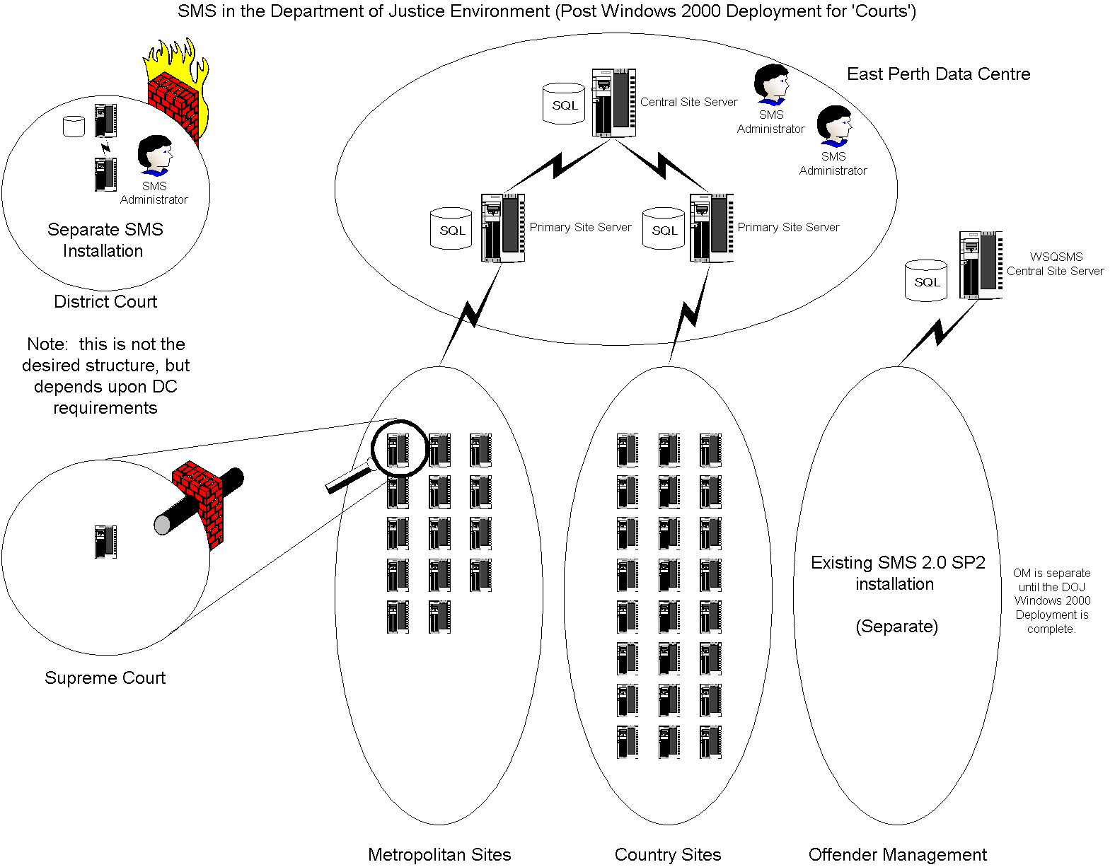
Figure 5.1a – SMS Hierarchy Structure (Pre OM W2K)

This design will not be final until after the Offender Management sites have been migrated to Windows 2000. This final design is presented below:

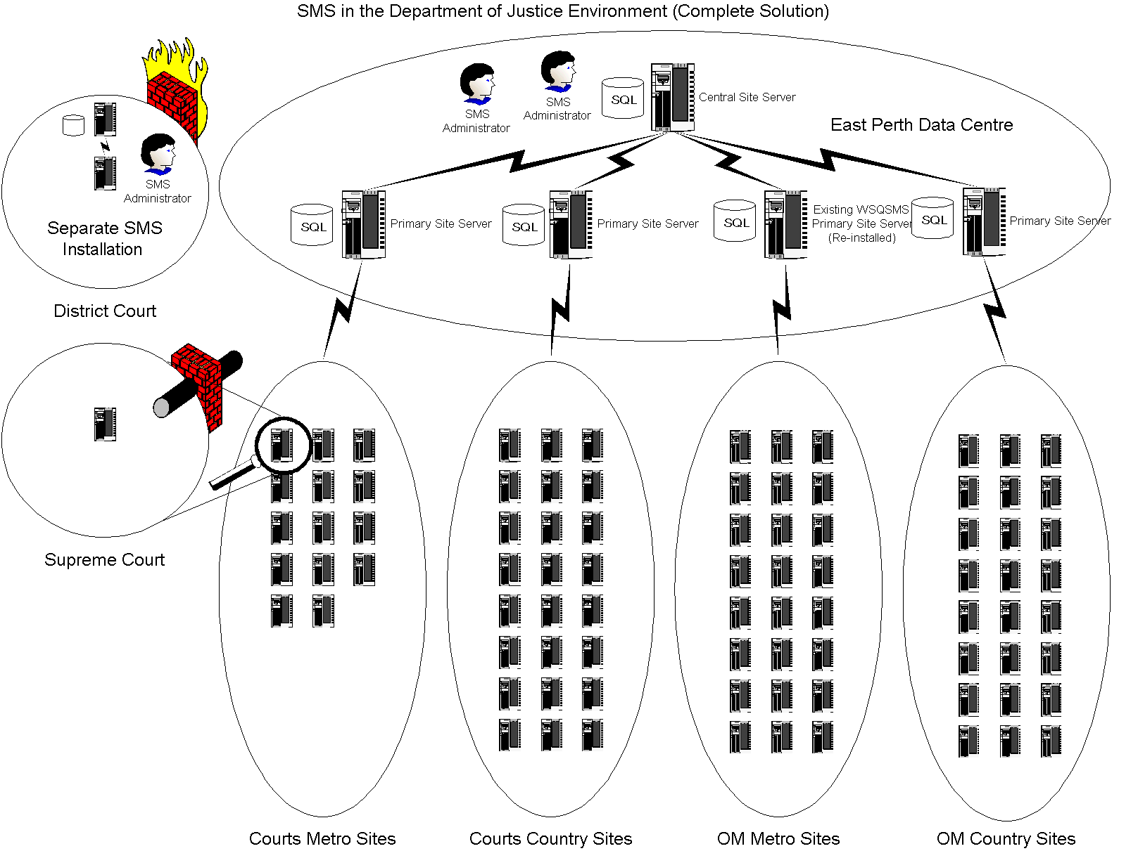
Figure 5.1b – SMS Hierarchy Structure (Post OM W2K)

5.1.2 Central Site Server

The most important server in any SMS installation is the central site server. This server houses data for the entire organisation and controls the operation of all child sites. As such, it must have sufficient hardware resources to do the job. A table showing minimum hardware specifications for site servers appears in Appendix B.

There already exists a functioning central site server that forms part of the SMS implementation for Offender Management. It currently has 40 secondary sites attached to it and houses data for 1800+ workstations/servers. It is feasible that this server could act as the central site server for the Courts SMS installation, but due to the timing of the OM Windows 2000 rollout, this is not possible.

5.1.3 Primary Site Servers

The primary site servers allocated to the Courts SMS installation will be the workhorses of the operation. They will process data from the secondary sites that report to them, and these are scattered throughout Western Australia. The Secondary Site Servers then pass their information to the central site server. They are also the control point for all their child sites as all configuration changes are routed through these sites.

At present, there are no servers available to take on this important role. Two servers will have to be purchased or allocated to fill this role. A table showing minimum hardware specifications for site servers appears in Appendix B.

5.1.4 Secondary Site Servers

Given the current network infrastructure, it is proposed that the Courts division will require 37 SMS secondary sites in order to service their 750+ workstations. Each secondary site server will look after the clients within its site boundaries, and any change in client configuration will be routed through these site systems.

The secondary site servers do not have to be dedicated machines. Therefore, it is feasible that the existing resource servers could do the job. A table showing minimum hardware specifications for site servers appears in Appendix B.

5.1.5 Site Server Locations

The following table outlines the Courts SMS sites..

Site Name | Site Type | Parent Site
East Perth Data Centre | Central | N/A
Country Courts | Primary | East Perth Data Centre
Metro Courts | Primary | East Perth Data Centre
Albany Court | Secondary | Country Courts
Armadale Court | Secondary | Metro Courts
AXA Building | Secondary | Metro Courts
Broome Court | Secondary | Country Courts
Bunbury Court | Secondary | Country Courts
Busselton Justice Complex | Secondary | Country Courts
Carnarvon Court | Secondary | Country Courts
Central Law Courts | Secondary | Metro Courts
Childrens Court | Secondary | Metro Courts
Coroners Court | Secondary | Metro Courts
Derby Court | Secondary | Country Courts
District Court | Secondary | Metro Courts
Esperance Court | Secondary | Country Courts
Family Court | Secondary | Metro Courts
Fremantle Justice Complex | Secondary | Metro Courts
Geraldton Court | Secondary | Country Courts
Guardianship Board | Secondary | Metro Courts
Joondalup Court | Secondary | Metro Courts
Kalgoorlie Court | Secondary | Country Courts
Katanning Court | Secondary | Country Courts
Karratha Court | Secondary | Country Courts
Kununurra Court | Secondary | Country Courts
Mandurah Court | Secondary | Country Courts
Manjimup Court | Secondary | Country Courts
Merredin Court | Secondary | Country Courts
Midland Court | Secondary | Metro Courts
Moora Court | Secondary | Country Courts
Narrogin Court | Secondary | Country Courts
Northam Court | Secondary | Country Courts
Parole Board | Secondary | Metro Courts
Pinjarra Court | Secondary | Country Courts
Port Hedland Justice Complex | Secondary | Country Courts
Rockingham Justice Complex | Secondary | Metro Courts
Roebourne Court | Secondary | Country Courts
Small Claims Tribunal | Secondary | Metro Courts
Supreme Court | Secondary | Metro Courts
Westralia Square | Secondary | Metro Courts
Table 5.1 – Site Server Locations

5.1.6 Site Hierarchy Diagrams

For diagrams showing the proposed SMS site structure for Courts, see Appendix A.

5.2 SMS Features

It is proposed that the following SMS facilities will be implemented:

- Hardware Inventory
- Software Inventory

At this stage, software distribution and remote tools are not required. These features can be implemented at a later date if the need arises. Licence metering is not seen as an immediate objective, and should not be considered additional hardware is to be purchased.

5.3 SMS Site System Roles

SMS is comprised of several modules or site systems that interact with each other to form the complete product. This modularity allows SMS to be a distributed system, with different site systems residing on multiple disk partitions or even multiple servers. The main system roles are outlined below:

- Site Server – a set of shared file systems and services that interact to provide the core functions of a SMS installation.
- Client Access Point – a shared file system that acts as a connection point for client workstations/servers. Inventory data is passed from the client to the CAP, and configuration information is passed from the CAP to the client. It also contains the files required for the SMS client installation process.
- Logon Point – a shared file system from which the SMS client installation is initiated. It is also involved in the SMS client discovery process.
- Distribution Point – a shared file system that acts as a repository for software packages that are to be distributed to client workstations via the SMS software distribution facility.

5.3.1 Server Roles for Courts SMS Servers

As indicated earlier, a single server can perform all site system roles, or they can be distributed amongst several servers. With the Courts SMS implementation, it is envisaged that all site servers will perform all system roles, as well as providing file and print sharing facilities, and possibly logon authentication duties. The table below outlines the system roles undertaken by the SMS site servers.

 | System Role
Server Type | Site Server | Client Access Point | Logon Point | Distribution Point
Central | ☑ | ☑
Primary | ☑ | ☑ |  | ☑
Secondary | ☑ | ☑ | ☑¹ | ☑
Domain Controllers |  |  | ☑
Member Servers |  |  |  | ☑²
¹ If the server is a domain controller in the logon domain ² Possible distribution point
Table 5.3 – Site System Roles

5.3.2 Hardware Required for Server Roles

The Courts servers that have been targeted as potential SMS site servers will require additional resources beyond what is required for normal file and print operations. The following table outlines the resources that each system role requires for normal operation. These specifications are based on an earlier SMS design document for Offender Management and are open for discussion. The specifications for the new Courts servers already exceed the minimum hardware required.

Site System Role | Minimum Resources Required
Primary Site Server | Dual 500MHz processors, 1G RAM, 54GB disk space (dedicated machine)
Secondary Site Server | Single 500MHz processor, 256M RAM, 9GB reserved disk space
Client Access Point | 64M RAM, 200MB reserved disk space
Logon Point | 64M RAM, 100MB reserved disk space
Distribution Point | 9GB reserved disk space (shared with SOE installer resources)
Table 5.4 – Hardware Resources for Server Roles

5.4 SMS Site Configuration

The following sections outline the properties to be assigned to Courts SMS sites. It must be stated that these are guidelines only, and must be more specifically defined using up-to-date information before implementation begins.

5.4.1 SMS Site Naming

Each SMS site must have a unique identifier associated with it. This identifier is in the form of a three-character code and is referred to as the SMS site code. It is also possible to assign a text site name and description to each site.

A full list of potential site codes is listed in Appendix C.

5.4.2 SMS Site Boundaries

Site boundaries are vital to the operation of SMS because they determine which workstations belong to which site. The boundaries are defined as IP subnets and this information is passed to all logon points. When a workstation attempts to become a SMS client, its IP address is checked against the site boundaries of every site. If it conforms to a boundary, it is assigned to that site and the installation process continues. If a workstation is not assigned, the client installation process fails to complete.

The Site Boundaries can be set in the Site Properties section of each installed site. It is proposed that only secondary sites will have boundaries assigned. Some Courts secondary sites will have more than one site boundary to accommodate additional subnets at that same physical location. It should be noted that SMS site boundaries do not function correctly if zero-subnets are used. Therefore, the Courts network structure must not utilise zero-subnet addresses.

A full list of proposed site boundaries can be found in Appendix C.

5.4.3 SMS Site System Accounts

SMS requires several user accounts in order to function normally. Some of these are generated during installation and should not be tampered with, some can be adjusted and some are optional. Other than the set of default accounts used, it is proposed that an additional Client Installation account be generated to aid the client installation process. SMS will use this account for client installation (during server discovery and call-back) (SMS will default to using the SMS service account if this fails).

A table of SMS accounts is available in Appendix D.

5.4.4 Client Configuration for Workstations

It is possible to configure each client agent as it is installed onto the workstations. The table below shows proposed configuration for the agents that are going to be used in the Courts SMS deployment. These settings are for workstations only.

SMS Agent | Global Configuration
Client Discovery | Logon discovery will not be used as it generates too much network traffic
Heartbeat Discovery | Heartbeat discovery will have a refresh interval of one week. This refreshes information in the SMS database and has minimal impact on the client machines.
Client Installation | Windows Logon Installation will be used to install client software. It works via a logon script which means it can be accomplished in a controlled manner.
Hardware Inventory | Hardware inventory will be configured to run once a week.
Software Inventory | Software inventory will be configured to run once a week.
Table 5.5 – Client Configuration for Workstations

5.4.5 Client Configuration for Servers

The SMS client software can be installed on servers and functions in the same way as on workstations. The table below shows the proposed configuration for the agents that are going to be used in the Courts SMS deployment.

SMS Agent | Global Configuration
Client Discovery | Logon discovery will not be used as it generates too much network traffic
Heartbeat Discovery | Heartbeat discovery will have a refresh interval of one week. This refreshes information in the SMS database and has minimal impact on the client machines.
Client Installation | Windows NT SMS Server Discovery will initiate the client installation automatically. Windows Logon Installation is for workstations only, so it is important that Group Policy is used to differentiate between workstations and servers.
Hardware Inventory | Hardware inventory will be configured to run once a week.
Software Inventory | Software inventory will be configured to run once a week.
Table 5.6 – Client Configuration for Servers

5.4.6 SMS Site System Configuration

All SMS sites have various settings that can be configured. The following table outlines proposed settings for the Courts SMS sites.

SMS Site Server
Property | Value
SMS Service Account | SMS service account created for site (see Appendix D)
SMS Client Installation Account | SMS client installation account created for site. It will default to the SMS service account upon failure (see Appendix D)
SQL Server Account | Only used at the central and primary sites
Parent Site | All sites will be set to the site code of the primary site (see Appendix C)
Boundaries | These will be the list of IP subnets in use at the site (see Appendix C)
SMS Site Server Installation Directory | Local drive D:\SMS
SMS Client Access Point
No changes will be made to the default configuration
SMS Logon Point
No changes will be made to the default configuration
SMS Distribution Point
Property | Value
SMS Distribution Point Directory | Local drive. Note that this only important if software distribution is going to be implemented.
Table 5.7 – Site System Configuration

5.4.7 Inter-site Communication

For SMS to function correctly, it must be able to communicate freely between installed site servers. This communication path allows the transferral of data from secondary sites to primary sites and vice-versa. Common data transferral includes discovery data, inventory data, client configuration information and site control files.

SMS uses the concepts of Addresses and Senders to create a communication path between sites. For two sites to communicate with each other, they must have an address for the other site, and a sender.

An Address has the following attributes:

- Destination SMS site code
- Destination server name
- Windows account to use for access
- Priority level
- Optional schedule for restricting network access
- Optional rate limits for restricting network usage

An address will be created at the primary site for each of the secondary sites, and each secondary site will have one address for the primary site. Each address can be configured to control the amount of bandwidth that SMS uses. At this stage, it is proposed that the addresses initially be left with default settings and the network links be monitored over a substantial timeframe. If it becomes apparent that SMS is utilising too much of the link, the addresses can be easily configured to decrease the bandwidth used. The default settings are:

- Schedule – open for all priorities 24 hours a day
- Rate Limits – unlimited when sending to this address

SMS has five types of sender that can be used to transport data between sites. These are:

- Standard
- Asynchronous RAS
- Isdn RAS
- X25 RAS
- SNA RAS

It is proposed to use the Standard Sender to connect sites in the Courts SMS implementation.

5.5 SMS Security

Security for the Court SMS implementation can be broken down into three categories – domain security, SQL database security and operational security. These are discussed in the following sections. General information concerning passwords is given in section 5.5.4.

5.5.1 Domain Security

Windows domain and machine security is addressed through Windows accounts – both domain and local. A list of the proposed accounts to be used in the Courts SMS deployment can be found in Appendix D. These accounts attempt to comply with the security requirements of the Department of Justice, as well as to balance a high level of security against the complexity of administration tasks.

During the Courts rollout, it is planned to have all resources in a single domain that will have a joint logon and resource role. With this in mind, there are two approaches to domain security. These are:

- Create a single domain-wide account that has access to all workstations and servers. This approach would be easy to implement and would reduce the complexity of administrative tasks, but it would have global implications if a security breach were to occur.
- Create a separate account per SMS site that has access only to the resources within the respective site boundaries. This approach contains the damage if a security breach occurs, but it makes administrative tasks exceedingly complex.

It is proposed that the single account approach be taken, but this can be revisited when the security model for the rollout has been agreed upon.

5.5.2 SQL Database Security

The proposed SMS hierarchy for the Courts division includes multiple primary site servers. These servers will have an installation of SQL Server 2000 which is used to store data from all resources in the SMS structure. SMS uses a single SQL Server account to access the SQL database at a primary site. This is usually set to the sa account during SMS installation, but it can be changed afterwards. To enable SQL Server 2000 inter-operability with SMS, Mixed Mode Authentication must be used.

5.5.3 SMS Operational Security

SMS is administered and configured through the SMS Administration Console, which is a snap-in for the Microsoft Management Console (MMC). The console has an ‘object’ security model which allows security to be applied at a task level. An example of this would be to ‘lock-down’ the ability of certain users to modify a particular query. This ‘object’ model gives the SMS administrator a very flexible and granular approach to operational security.

It is also possible to customise the MMC to display selected components of the SMS Administration Console. This means it is possible to configure consoles based on operational role. For example, if a staff member was assigned to software distribution, a console could be designed to show workstation collections and the packaging sections. Everything else would be hidden making it impossible for the user to change vital site configuration parameters.

At this stage, it is proposed that there will be two levels of access for the Courts SMS implementation, and these are listed below. The finalisation of SMS support roles may uncover additional roles that may be added to this security design.

Function | Description
SMS Administrator | This resource undertakes the installation and maintenance of SMS, configures all properties and performs specific inventory operations. The SMS Administrator requires Full Control rights over every object in the SMS hierarchy.
Client Manager | This resource is the designated manager(s) for the Courts division. They may require access to SMS to keep a track on assets. The Client Manager role requires Read rights to objects in the SMS hierarchy.
Table 5.8 – SMS Resource Functions

5.5.4 SMS Account Names and Password Changes

In general, the accounts and associated passwords used by SMS services should not be allowed to expire or be changed. Components using these accounts are numerous and can exist at multiple locations. An unauthorised password or account name change has a risk of failure associated with it, and any failure can result in SMS becoming inoperable.

However, it is possible to change the SMS Service account and the SQL Server account and retain full SMS functionality. If so desired, an agenda can be put in place to change the passwords of these accounts on a six-monthly basis. Changing SMS Passwords is not recommended, though it is supported by Microsoft.

Windows accounts created for SMS should have the Password Never Expires option checked.

5.6 SMS Resourcing

For the SMS deployment at Courts, the operational processes can be broken into several areas. These are expected to comprise of:

- Installation and configuration (deployment)
- Administration
- Database administration

Roles such as software packaging and distribution and helpdesk are not included at this time because these features are not to be deployed during the Courts SMS rollout.

The installation and configuration role is a temporary one and is operational until the deployment is complete. The other roles are ongoing and are present for as long as the SMS installation is operational. Table 5.9 outlines staffing levels for the operational roles described above. These are estimates only and can be modified when more information is available.

Role | Time Required (Hours per Week) | Tasks
Deployment | 40, but only for the deployment phase | Installation and configuration of all SMS sites in the Courts division
SMS Administration | 40 ongoing (full-time resource) | Daily operation of SMS including database maintenance, site server and client management, inventory processing and reporting, and backups.
SQL Administration | 2 ongoing | Maintenance of SQL Server 7.0 installation.
Table 5.9 – SMS Required Resources

5.7 Additional Software

The Crystal Reports software that is packaged with SMS is not sufficient to produce reports when greater than 500 clients are installed. Therefore, it is suggested that an additional reporting tool be implemented to produce standard and customised reports.

There is a utility called the SMS Web Reporting Tool that is free and has already been implemented in the OM SMS installation. It is a web-based tool (using Microsoft Internet Information Server) and has proved to be excellent for producing quality reports. It is proposed that this tool be used with the Courts SMS deployment.

6.0 RECOMMENDATIONS AND TASKS REQUIRED FOR SMS DEPLOYMENT

This section presents some recommendations with regard to the reliable operation of SMS when it is deployed into the Courts environment. It also outlines the tasks required to complete the Courts SMS implementation.

6.1 Recommendations

The following sub-sections summarise recommendations for the Courts network architecture. They are put forward as proposals only and are subject to further discussion.

6.1.1 Placement of Windows Domain Controllers

Most sites will have a local domain controller. The only sites that may use a non-local domain controller are metro sites that are linked by high speed WAN connections e.g. East Perth Data Centre.

6.2 Tasks Required

Based on the assumptions that there will be no major change to the planned Courts infrastructure and that the recommendations given above are adopted, the following is a list of tasks that are required to be completed in order to successfully deploy SMS into the Courts division. These should be viewed as a series of tasks, with the start of each being dependent on the successful completion of the previous.

6.2.1 Finalising SMS Design

A number of areas covered by the SMS design (section 5.0) require further information and development before deployment can proceed. These are listed in the table below.

Design Area | Information and Work Required
SMS Server design | - Obtain server names, locations, functions and IP subnets
 | - Finalise site coding
 | - Develop a site server role plan
 | - Obtain fixed disk and logical drive structures
 | - Finalise reserved SMS logical drive and size
 | - Verify time synchronisation
Windows Domain Design | - Verify single domain structure
 | - Finalise naming and use of SMS accounts
Courts Network Design | - Obtain IP addressing plan
 | - Finalise SMS restrictions for WAN links
 | - Develop SMS site addressing configuration
SMS Operation | - Finalise inventory data to be collected
 | - Finalise SMS site configuration
 | - Finalise the reporting system including design of reports
 | - Develop and document SMS operating procedures
Table 6.1 – Finalising SMS Design

6.2.2 SMS Test Site

Before the Courts SMS design is deployed into the production environment, it is important to fully test the functionality of SMS in a test environment. The test lab will mirror the proposed production environment as closely as possible to get a true indication of SMS performance. However, it may not be possible to imitate the existence of WAN links.

The equipment requested to build the test lab is as follows:

- One Windows 2000 server for use as a SMS primary site server
- One Windows 2000 server for use as a SMS secondary site server
- Five Windows 2000 workstations for use as SMS clients
- One hub or switch to provide network connectivity

Both site servers will be domain controllers and the secondary site will run DHCP. The secondary site server will have boundaries set for the site, and the primary site server will act purely as a data storage point.

The SMS test programme will seek to accomplish the following:

- Test remote secondary site installation process
- Test Courts workstation installation through logon scripts
- Test Windows SMS Server Discovery
- Test SMS Hardware Inventory process
- Test SMS Software Inventory process

6.2.3 Finalisation of SMS Configuration and Procedures

Changes to the final configuration and procedures for the Courts SMS implementation are expected, and will result from finalisation of the Courts infrastructure and the test exercise. It is recognised that the SMS design outlined in this document is flexible, and that changes will be included as the need arises.

6.2.4 SMS Deployment

As each Courts site is rolled out, SMS will be deployed at the same time. The process for a typical Courts site is summarised in the table below. Note that the tasks are listed in order of completion.

Order | Task | Person Responsible
1 | Completion of Courts SOE server | SOE Rollout Team
2 | Installation of SMS secondary site onto new server | SOE Rollout Team
3 | Completion of SOE workstation rollout | SOE Rollout Team
4 | Enable Windows Logon Installation at site | SMS Administrator
5 | Verify client installation on all workstation | SMS Administrator
6 | Activate and configure inventory agents | SMS Administrator
7 | Verify collection of inventory data | SMS Administrator
8 | Declare SMS operational at site | SMS Administrator
Table 6.2 – SMS Deployment Tasks

6.2.5 Ongoing SMS Operation

Once the Courts SMS deployment has been completed, SMS will be used by the Department of Justice for asset tracking and collecting inventory data for the Courts division workstation/server fleet. To maintain and operate SMS effectively, dedicated resources need to be allocated to the project. Estimated required resourcing is shown below:

- SMS Administrator – full time position (40 hrs per week)
- SQL Administrator – part time position (7.5 hrs per week)

If the scope of the Courts SMS installation is extended to include software distribution, an additional resource may be required to perform software packaging and deployment.

APPENDIX A – SMS HIERARCHY DIAGRAMS

These diagrams will change, and are incorrect

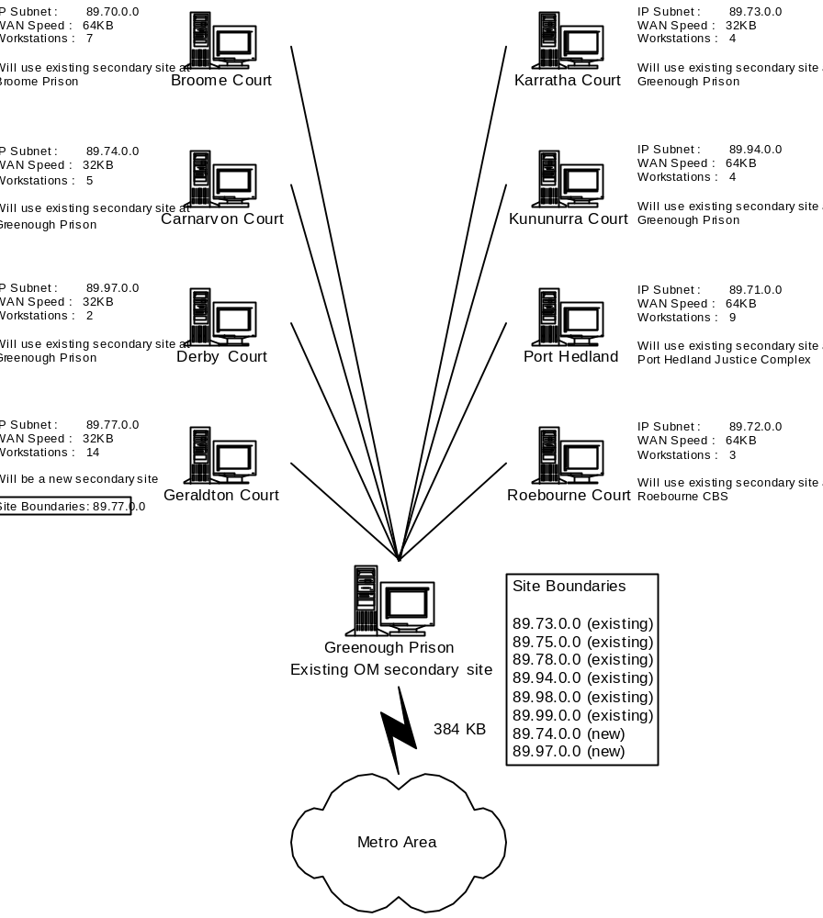
Figure A.1 – Courts Northern Sites

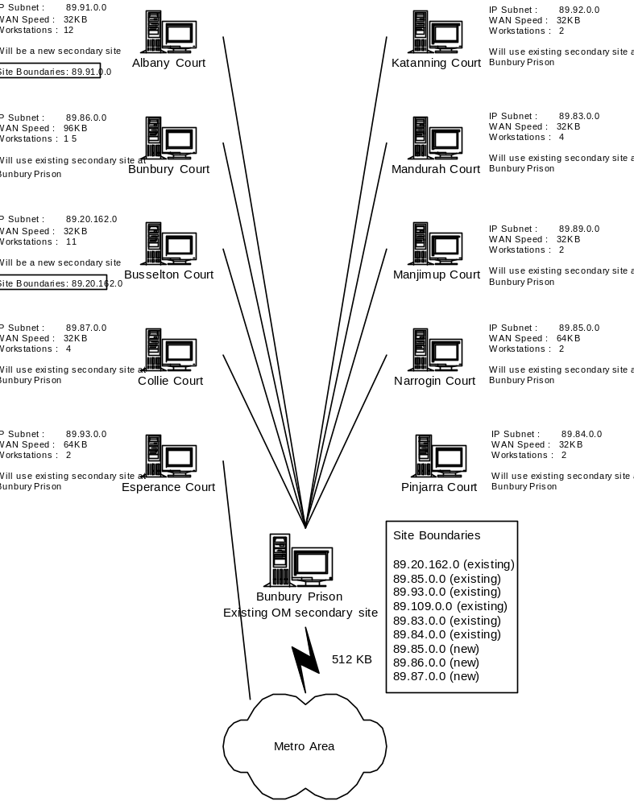
Figure A.2 – Courts Southern Sites

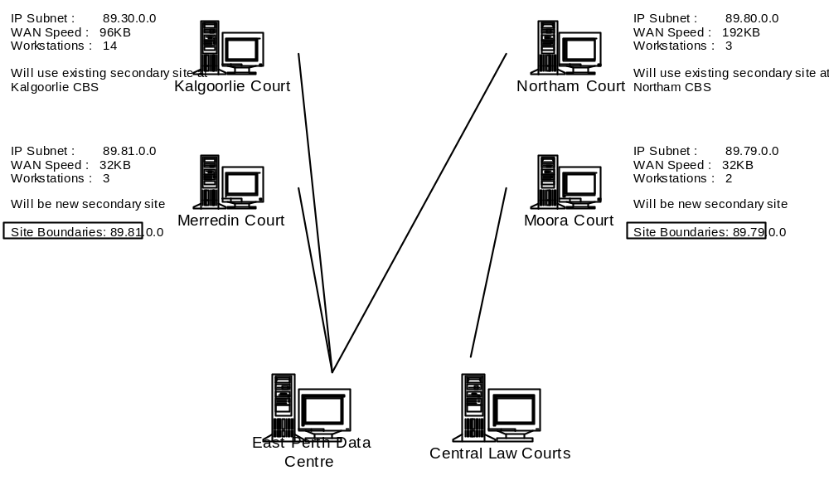
Figure A.3 – Courts Eastern Sites

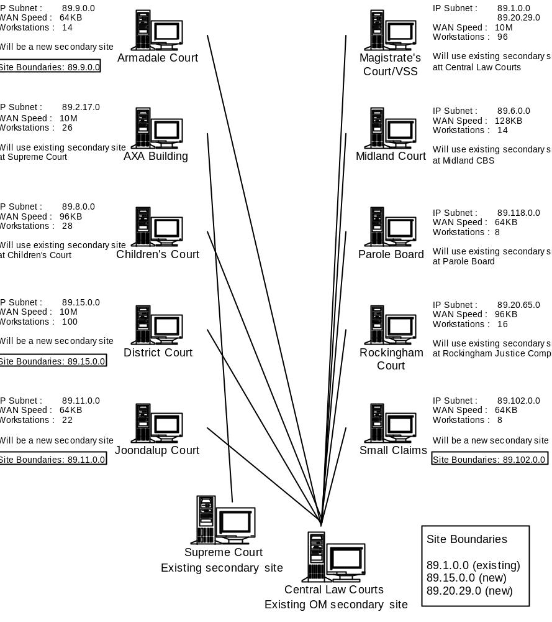
Figure A.4 – Courts Metro Sites (1)

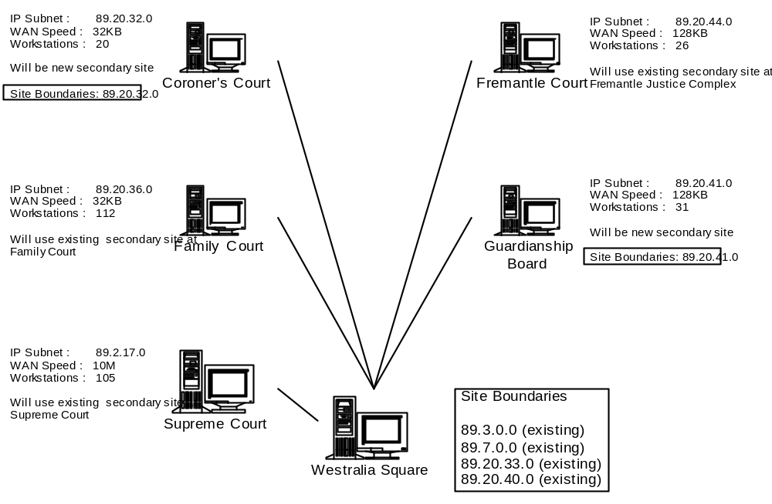
Figure A.5 – Courts Metro Sites (2)

APPENDIX B – MINIMUM HARDWARE SPECIFICATIONS

Central Site Server Hardware Specification

- Dual 500MHz Pentium III processors or equivalent
- 1GB of RAM
- 40GB of free fixed disk storage spread over at least three disks using hardware RAID 5
- Backup device capable of backing up the entire server

Primary Site Server Hardware Specification

- Dual 500 MHz Pentium III processors or equivalent
- 512MB of RAM
- 30GB of free fixed disk storage spread over at least three disks using hardware RAID 5
- Backup device capable of backing up the entire server

Secondary Site Server Hardware Specification

- Single 500MHz Pentium III processor or equivalent
- 256MB RAM
- 18GB of free fixed disk storage spread over at least three disks using hardware RAID 5
- Backup device capable of backing up the entire server

Client Workstation Hardware Specification

- 15MB of dedicated RAM
- 15MB of free fixed disk space

Additional Specifications

The proposed Courts SMS design calls for no central or primary site to have site boundaries, and therefore no clients will be assigned to these servers. All client activity will be routed through the secondary sites, and thus, all secondary site servers must have the following specifications:

- Must run Windows 2000 Server or Advanced Server with Service Pack 2
- Must function as a Windows domain controller
- Must have sufficient memory to run all SMS services
- Must be able to support over 100 SMS client workstations
- Must be able to provide file and print services to over 100 workstations

APPENDIX C – SMS SITE CONFIGURATION

This information is incorrect and will change to reflect the deployed architecture.

Site Name | Site Type | Site Code
Westralia Square | Primary | CTS
Albany Court | Secondary | ALC
Armadale Court | Secondary | ARM
Busselton Justice Complex | Secondary | BJC
Coroners Court | Secondary | COR
District Court | Secondary | DIS
Geraldton Court | Secondary | GEC
Guardianship Board | Secondary | GUA
Joondalup Court | Secondary | JOO
Merredin Court | Secondary | MER
Moora Court | Secondary | MOO
Small Claims Tribunal | Secondary | SCT
Table C.1 – SMS Site Codes

Site Name | Site Type | Site Boundaries
Westralia Square | Primary | None
Albany Court | Secondary | 89.91.0.0
Armadale Court | Secondary | 89.9.0.0
Busselton Justice Complex | Secondary | 89.20.162.0
Coroners Court | Secondary | 89.20.32.0
District Court | Secondary | 89.15.0.0
Geraldton Court | Secondary | 89.77.0.0
Guardianship Board | Secondary | 89.20.41.0
Joondalup Court | Secondary | 89.11.0.0
Merredin Court | Secondary | 89.81.0.0
Moora Court | Secondary | 89.79.0.0
Small Claims Tribunal | Secondary | 89.102.0.0
Table C.2 – SMS Site Boundaries

APPENDIX D – SMS ACCOUNTS

Account Name | SMS Account Name | Tasks | Rights
SMSService | SMS Service account | Used by SMS services to access SMS site systems in a SMS site | Local admins, log on as a service – on SMS site servers and CAP’s
SMSServer_xxx | SMS Server Network Connection account | Used by a number of SMS site services to access the SMS site server. Used by SMS site server services to access SMS site systems if the SMS Service account fails | Read permission to the \SMS directory, domain user, fullcontrol to the SMS_SITE share on the site server, permission to write DDR’s
SMSAddress_xxx | SMS Site Address account | Used to establish communications between SMS sites | Read, write, execute and delete permissions to the \Inboxes\Despooler.box on the destination SMS site server
SMSClient_xxx | SMS Client Network Connection account | Used by clients to connect to CAP’s and distribution points, transfer data and retrieve configuration settings | Read permission on CAP’s, logon points, write permission to the inboxes on CAP’s and logon points
SMSInstall | SMS Client Remote Installation Account | Used by SMS site services to remotely install the SMS client onto workstations | Local admins on target workstations, log on as a service – on SMS site servers and CAP’s
Table D.1 – SMS Accounts

APPENDIX E – GLOSSARY

Courts Site A physical location (street address) for Courts operations where a WAN link from DOJ Headquarters terminates at a LAN (providing network access to shared file and print facilities, as well as WAN communications).
CAP Client Access Point
DDR Data Discovery Record
DOJ Department of Justice
LAN Local Area Network
OM Offender Management
RAID Redundant Array of Independent Disks
RAM Random Access Memory
SMS Microsoft Systems Management Server v2.0 – a scalable network infrastructure system to enable the remote management of PC desktops.
WAN Wide Area Network

APPENDIX F – REFERENCES

Simon Manners Ministry of Justice SMS Design

Microsoft Press Microsoft Systems Management Server 2.0 Resource Guide

